Install Nagios Server on RHEL8 and add a remote linux host (ubuntu18.04) in Nagios server for monitoring

Below steps run on RHEL 8 OS to install Nagios
Disable SELINUX:
setenforce 0
dnf install nano -y
nano /etc/selinux/config
change enforcing -> disabled, save and close.
Reboot the machine
INSTALL PRE-REQS:

Install pre requisite software
dnf install httpd php php-cli gcc glibc glibc-common gd gd-devel net-snmp openssl-devel wget unzip -y

Add user & groud
useradd nagios
groupadd nagcmd
Add nagios and apache under group nagcmd
usermod -a -G nagcmd nagios
usermod -a -G nagcmd apache
DOWNLOAD & INSTALL NAGIOS:
cd /tmp
wget https://assets.nagios.com/downloads/nagioscore/releases/nagios-4.1.1.tar.gz
wget http://www.nagios-plugins.org/download/nagios-plugins-2.1.1.tar.gz
tar zxf nagios-4.1.1.tar.gz
tar zxf nagios-plugins-2.1.1.tar.gz
cd nagios-4.1.1
./configure --with-command-group=nagcmd
dnf install make -y
make all
make install
make install-init
make install-config
make install-commandmode
make install-webconf
htpasswd -c /usr/local/nagios/etc/htpasswd.users nagiosadmin
service httpd start
service nagios start
install PLUGINS:
cd /tmp/nagios-plugins-2.1.1
./configure --with-nagios-user=nagios --with-nagios-group=nagios --with-openssl
make all
make install
service nagios restart

Allow port 80 on security group or add below command for firewall approval if necessary
firewall-cmd --zone=public --add-port=80/tcp --permanent
firewall-cmd –reload

Login to Nagios web page
http://Server_IP/nagios/
Nagios login page is showing below
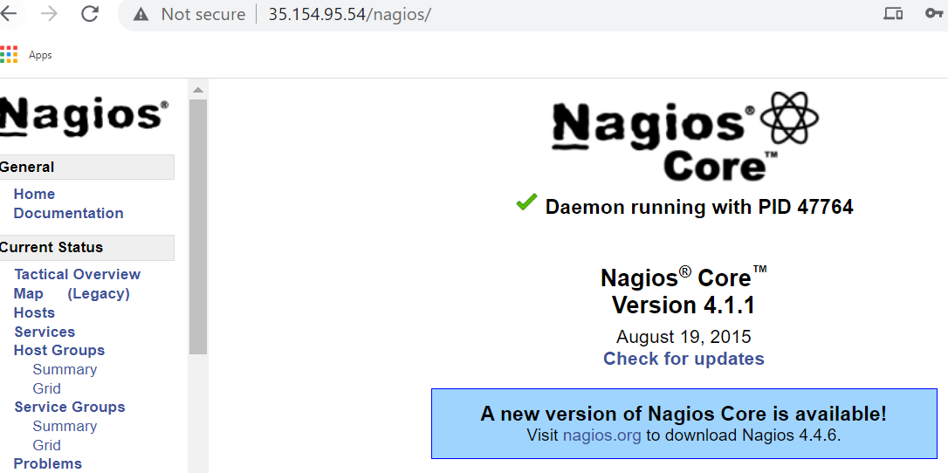

Troubleshoot :
Check below command to check whether nagios has cfg file has any error or not
/usr/local/nagios/bin/nagios -v /usr/local/nagios/etc/nagios.cfg

Nagios Core 4.1.1
Copyright (c) 2009-present Nagios Core Development Team and Community Contributors
Copyright (c) 1999-2009 Ethan Galstad
Last Modified: 08-19-2015
License: GPL

Website: https://www.nagios.org
Reading configuration data...
Read main config file okay...
Read object config files okay...

Running pre-flight check on configuration data...

Checking objects...
Checked 8 services.
Checked 1 hosts.
Checked 1 host groups.
Checked 0 service groups.
Checked 1 contacts.
Checked 1 contact groups.
Checked 24 commands.
Checked 5 time periods.
Checked 0 host escalations.
Checked 0 service escalations.
Checking for circular paths...
Checked 1 hosts
Checked 0 service dependencies
Checked 0 host dependencies
Checked 5 timeperiods
Checking global event handlers...
Checking obsessive compulsive processor commands...
Checking misc settings...

Total Warnings: 0
Total Errors: 0

Things look okay - No serious problems were detected during the pre-flight check

Check nagios server version
/usr/local/nagios/bin/nagios -v

Nagios Core 4.1.1
Copyright (c) 2009-present Nagios Core Development Team and Community Contributors
Copyright (c) 1999-2009 Ethan Galstad
Last Modified: 08-19-2015
License: GPL

Below steps to add remote ubuntu server (18.04) to nagios server
Use the following command to install NRPE Add-on and Nagios plugins.
sudo apt update

sudo apt install -y nagios-nrpe-server nagios-plugins

Configure NRPE Add-on
/etc/nagios/nrpe.cfg
### Ubuntu / Debian ###

sudo nano /etc/nagios/nrpe.cfg
Add the Nagios servers IP address, separated by comma like below.
allowed_hosts=192.168.0.10

Configure Nagios Checks
Ubuntu / Debian
sudo nano /etc/nagios/nrpe.cfg
# COMMAND DEFINITIONS

...
...

command[check_users]=/usr/lib/nagios/plugins/check_users -w 5 -c 10
command[check_load]=/usr/lib/nagios/plugins/check_load -w 15,10,5 -c 30,25,20
command[check_root]=/usr/lib/nagios/plugins/check_disk -w 20% -c 10% -p /
command[check_swap]=/usr/lib/nagios/plugins/check_swap -w 20% -c 10%
command[check_total_procs]=/usr/lib/nagios/plugins/check_procs -w 150 -c 200

Test Nagios Checks
Ubuntu 18.04:
/usr/lib/nagios/plugins/check_procs -w 150 -c 200
Output:
PROCS WARNING: 190 processes | procs=190;150;200;0;

Change warning to 200 and critical to 250 for testing purposes. Now you will see an OK message.
/usr/lib/nagios/plugins/check_procs -w 200 -c 250
Output:
PROCS OK: 189 processes | procs=189;200;250;0;

Restart the NRPE service.
### Ubuntu / Debian ###

sudo systemctl restart nagios-nrpe-server

Allow port 5666 at security group or firewall

On Nagios Server

CentOS / RHEL
Nagios NRPE plugin is available in the EPEL repository for CentOS / RHEL. So, configure the EPEL repository your CentOS / RHEL system.
rpm -ivh https://dl.fedoraproject.org/pub/epel/epel-release-latest-8.noarch.rpm

Use the following command to install the NRPE plugin on your machine.
yum -y install nagios-plugins-nrpe

Edit Configuration
### CentOS / RHEL ###

vi /usr/local/nagios/etc/nagios.cfg

Add or uncomment the following line.
cfg_dir=/usr/local/nagios/etc/servers

Create a configuration directory.
### CentOS / RHEL ###

mkdir /usr/local/nagios/etc/servers

Add Command Definition
Now it’s time to configure the Nagios server to monitor the remote client machine, and You’ll need to create a command definition in Nagios object configuration file to use the check_nrpe plugin.
Open the commands.cfg file.
CentOS / RHEL
vi /usr/local/nagios/etc/objects/commands.cfg
Add the following Nagios command definition to the file.
# .check_nrpe. command definition
define command{
command_name check_nrpe
command_line /usr/lib64/nagios/plugins/check_nrpe -H $HOSTADDRESS$ -t 30 -c $ARG1$
}

Add a Linux host to Nagios server
Create a client configuration file /usr/local/nagios/etc/servers/ubuntu.cfg to define the host and service definitions of remote Linux host.
### CentOS / RHEL ###

vi /usr/local/nagios/etc/servers/ubuntu.cfg

Copy the below content to the above file.
You can also use the following template and modify it according to your requirements. The following template is for monitoring logged in users, system load, disk usage (/ – partition), swap, and total process.
define host{

use linux-server
host_name ubuntu_machine
alias ubuntu_machine
address 10.0.0.38

}

define hostgroup{

hostgroup_name linux-server
alias ubuntu_machine
members ubuntu_machine
}

define service{

use local-service
host_name ubuntu_machine
service_description SWAP Uasge
check_command check_nrpe!check_swap

}

define service{

use local-service
host_name ubuntu_machine
service_description Root / Partition
check_command check_nrpe!check_root

}

define service{

use local-service
host_name ubuntu_machine
service_description Current Users
check_command check_nrpe!check_users

}

define service{

use local-service
host_name ubuntu_machine
service_description Total Processes
check_command check_nrpe!check_total_procs

}

define service{

use local-service
host_name ubuntu_machine
service_description Current Load
check_command check_nrpe!check_load

}
Verify Nagios for any errors.
### CentOS / RHEL ###

/usr/local/nagios/bin/nagios -v /usr/local/nagios/etc/nagios.cfg

Restart the Nagios server.
### CentOS / RHEL ###

systemctl restart nagios

Results:
At Nagios Web GUI new ubutu host has added , from nagios GUI hosts and services section we can display ubuntu_machine and corresponding services as showing below
